
Covid-19 (SARS-CoV-2) Medical Certificate
Fit to Fly
Patient:  Date of Birth: | Chinweuche Nwogu  18/06/1980
PIN: | 5558150
Passport/ID Card Number: | A07197157
Testing Address: | Better2Know - The Doctors Laboratory
Date of Analysis: | 12/10/2022
Certificate validity: One month from Date of Analysis
The above patient underwent testing for the Covid-19 (SARS-CoV-2) virus. The testing method used was Reverse Transcription polymerase chain reaction (RT-PCR), sensitive to < 100 RNA copies.
The test results were:
Covid-19 (SARS-CoV-2) ……..…………… Not Detected (See pathology report) There is no evidence of infection in this patient.
Confirmed by:
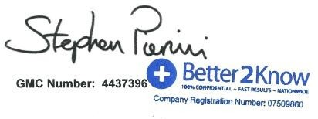
Dr Stephen Pierini GMC: 4437396 Medical Director Better2Know Ltd.

Better2Know Ltd, Enterprise House, Unit 1, Kirkby Lonsdale Business Park, Kirkby Lonsdale, Cumbria LA6 2GT
Booking Line: 0207 099 0955 | E: info@better2know.co.uk | T:@Better2Know_ltd

Better2Know Ltd, Enterprise House, Unit 1, Kirkby Lonsdale Business Park, Kirkby Lonsdale, Cumbria LA6 2GT
Booking Line: 0207 099 0955 | E: info@better2know.co.uk | T:@Better2Know_ltd
Powered by TCPDF (www.tcpdf.org)

